I think this is correct. Not sure though.

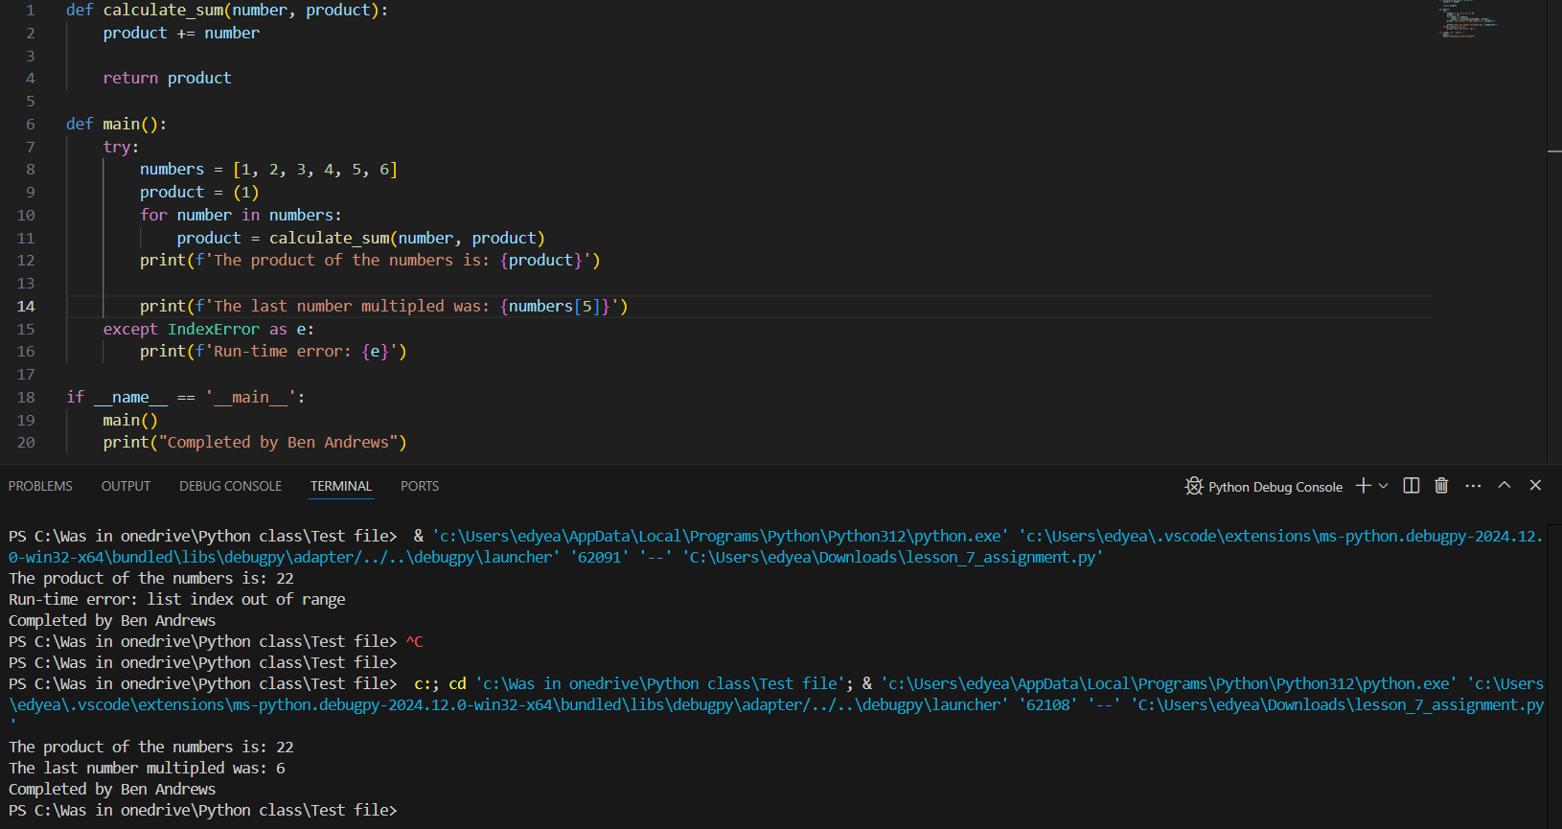

def calculate_sum(number, product):

product += number

return product

def main():

try:

numbers = [1, 2, 3, 4, 5, 6]

product = (1)

for number in numbers:

product = calculate_sum(number, product)

print(f'The product of the numbers is: {product}')

print(f'The last number multipled was: {numbers[5]}')

except IndexError as e:

print(f'Run-time error: {e}')

if __name__ == '__main__':

main()

print("Completed by Ben Andrews")